ABRIDGED LEARNING AND DEVELOPMENT SYSTEM
FOR TEACHER PROFESSIONAL DEVELOPMENT

PART VI: LEARNING AND DEVELOPMENT PROGRAM DELIVERY (LDD)

Sustaining Education Reform Gains (SERG)

16 July 2020
Draft Version 3
(with Inputs from Validation)




Table of Contents

Acronyms
INTRODUCTION ……………………………………………………………………………………………………………………………. 1
PART VI: LEARNING AND DEVELOPMENT DELIVERY FOR TEACHER PROFESSIONAL DEVELOPMENT
- Definition ………………………………………………………………………………………………………………………… 2
- Purpose …………………………………………………………………………………………………………………………… 2
- LDD General Guidelines …………………………………………………………………………………………….……. 3
- LDD Key Processes ………………..………………………………………………………………………………………… 4
  - Pre-delivery …………………………………………………………………………………………………………….. 4
  - Delivery …………………………………………………………………………………………………………………… 4
  - Post-delivery …………………………………………………………………………………………………………… 5
- Annexes
Annex A – L&D Program Management Structures ……………………………..………………………….. 8
Annex B - L&D Intervention Completion Report Template …………………..………………………… 12
- Reflection Questions
- For School Head …………………………………………………….………………………………………………… 14
- For TPD Coach ………………………………………………………….……………………………………………… 15
- For SDO Focal …………………………………….………………………………………………………………….. 16
- For RO Focal …………………………………..……………………………………………………………………….. 17

INTRODUCTION

Providing quality basic education for all Filipino learners is the core business of the Department of Education (DepEd). While numerous factors affect the provision of quality education, crucial to learner performance is the quality of teachers and of the teaching-learning process.

In launching “Sulong EduKalidad,” on December 3, 2019 DepEd Secretary Leonor Magtolis Briones said “the first letters of the four pillars of Sulong Edukalidad form the word KITE with its commitment to help our learners achieve their full potential, for their kite of dreams to fly high through quality basic education for all.” Letter T stands for the first word of the third pillar which is Teachers’ upskilling and reskilling.

It is thus timely that the Department of Education embarked on education initiatives towards improving teacher quality with the support of the Australian Government Department of Foreign Affairs and Trade (DFAT). Initiatives which were started in the Basic Education Sector Transformation (BEST) Program included the introduction of the Philippine Professional Standards for Teachers (PPST), strengthening of the National Educators Academy of the Philippines (NEAP), the development of a new Learning and Development (L&D) System for educators, and a broad range of Teacher Professional Development (TPD) programs.

The SERG project (2019-2021) seeks to extend and sustain these education initiatives by continuing pilot implementation in six selected schools in two Schools Divisions in Regions V, VI, VIII and X.

This abridged version of the “Learning and Development System” focuses on guiding School Heads in implementing the system and each of its subsystems towards Teacher Professional Development (TPD). It utilizes other existing systems in the Department such as the Results-based Performance Management System (RPMS), the Philippine Professional Standards for Teachers (PPST), Instructional Supervision and Classroom Observation as well as existing data sources. It seeks to facilitate the identification of learning needs and appropriate learning interventions while engaging teachers in their own professional development and building a learning community within the school.

The objective of the system implementation is to improve the competencies of teachers leading to an improved teaching quality and increased learners’ performance.

The Learning and Development System is comprised of seven parts for the seven sub-systems namely:

Part I – Governance and Enabling Mechanism (GEM)
Part II – Learning and Development Needs Assessment (LDNA)
Part III – Learning and Development Planning (LDP)
Part IV – Learning and Development Program Designing (LDPD)
Part V – Learning and Development Resource Package Development (LDRPD)
Part VI – Learning and Development Program Delivery (LDD)
Part VII – Learning and Development Quality Assurance, Monitoring and Evaluation (LDQAME)

Thus, this compilation of booklets are the seven parts of the Learning and Development System.
This booklet is Part VI-Learning and Development Program Delivery for Teacher Professional Development.

PART VI: LEARNING AND DEVELOPMENT PROGRAM DELIVERY
FOR TEACHER PROFESSIONAL DEVELOPMENT

Definition

L&D Program Delivery (LDD) is the subsystem for implementing the intervention for teachers considering their personal, family or work-related circumstances and based on the approved design using the learning resource package that has been developed to achieve their learning/enabling objectives for unique and common needs.

Purpose

The subsystem provides processes and standards for implementing the various tasks before, during, and after the conduct of a responsive L&D intervention to ensure teachers’ access and active participation, realization of their learning/enabling objectives, and use of resources in the most equitable, efficient and effective manner.

LDD General Guidelines

  - LDD is a collaborative process involving the school head and program management team; while for LAC and formal training, the program owner and learning service providers (facilitators, resource persons, coaches, mentors, etc.) are also involved.
  - The LDD is teacher-centered and need- and context-based.
  - The LDD ensures adherence to the approved design for the identified individual learners and the number of target learners in formal learning modalities for different groups as follows:
    - L&D interventions with skills-building objectives (e.g., training course): 15-30
    - L&D interventions with mainly information or knowledge diffusion objectives (e.g., seminar): maximum of 50
    - Learning Action Cell: 2 to 15
  - LDD adheres to adult learning principles and conditions.
  - Feedback and reflection are embedded in every learning modality.
  - Only DepEd-recognized programs and courses shall be implemented and delivered for teacher professional development (TPD) in alignment with DepEd Order No. 1, s. 2020.
  - LDD ensures immediate and effective classroom application or innovations of learning gained through action plans or re-entry plans.
  - LDD Program Management Team (PMT) structure and composition is adequate in number and meets competency requirements for assigned roles. The roles of the PMT are specified in the Governance and Enabling Mechanisms (GEM) subsystem of the Abridged L&D Manual. The composition of the PMT varies according to the type of modality. (See Annex A-Program Management Structures p.8).
  - Learning service providers (e.g., learning facilitators, resource persons, etc.) are adequate in number and meet competency requirements for assigned roles based on NEAP’s recognition and authorization process.
  - LDD ensures equitable access and participation of teachers in the approved learning modalities which are responsive to the teachers’ personal or family circumstances, location and conditions of work assignments, particularly those in disadvantaged areas or difficult circumstances. This implies the provision of reasonable accommodation and removal of constraints, barriers and various forms of gender-based discrimination with respect to women’s access and participation.
  - LDD ensures that women teachers are made equal to male teachers in pre, during, and post implementation activities.
  - LDD observes and promotes gender sensitivity, equality, equity, non-violence against women and their children and uses gender-fair language (DO 32, s. 2017).
  - LDD observes and promotes child protection to prevent abuse, neglect, exploitation, discrimination and violence. (DO 40, s. 2012)
  - LDD ensures that teachers and intervention implementers shall maintain an inclusive atmosphere and promote respect at all times (DO 21, s. 2019).

LDD Key Processes

The key processes in the delivery of any learning intervention are clustered into three phases: pre-delivery, delivery, and post-delivery. Tasks on management of the intervention, resources, and learning are carried out along these three phases.

The following processes guide the conduct of any learning and development intervention (JEL, RDL, LAC, or formal training) to address the unique and common needs of teachers:

Pre-delivery

Based on the approved design and resource learning package, set the schedule of the intervention, prepare logistics and resources (training materials/hand-outs, training/conference venue, and equipment needed), coordinate with participants, and ensure briefing of resource persons (for LAC and formal training).

Delivery
JEL/RDL | LAC | Formal Training
Implement JEL or RDL with teacher/s. | Conduct LAC based on the LAC plan. | Conduct formal training and monitor progress along objectives.
Help the teacher/s identify next steps for further development, applying and sustaining learning through the Workplace/Classroom Application Project (W/CAP) plan | Plan activities in the classroom for the application of learning and identify what to present in the next session to assess the outcome of instruction (W/CAP plan) | Prepare W/CAP plan or its equivalent

The Workplace/Classroom Application Project (W/CAP) shows how learners can apply newly acquired competencies. It is directly aligned with the target competencies for development; will provide opportunities for demonstration of newly acquired competencies; can be realistically completed within six months using available resources in the workplace; and is approved by the immediate supervisor/s where learners are based. Funding support, if needed, is available to implement the W/CAP.

Post-delivery

JEL/RDL | LAC | Formal Training
Accomplish and have the coach/mentor/facilitator certify the L&D modality form to be noted by the SH and submit to PMT | After completing all sessions based on the LAC implementation plan, have the completion form certified by the LAC leader and noted by the SH, and submit to PMT
 | Prepare post-intervention report | Prepares post-intervention report (including evaluation results and financial report)
Monitor the results of the application in the classroom or in the teacher’s personal/professional life.

(See Annex B for L&D Intervention Completion Report Format p.12).

The type of program management structure for learning and development interventions depends on the delivery modality, coverage, duration, location, and the size of target group of learners. (See Annex B).

As follows is the simplified process of L&D program delivery.

Figure 1. L&D Program Delivery
Output
Process
Input

Approved intervention design and resource materials for JEL and RDL to address teachers’ unique needs

School head/other instructional leaders implement JEL or RDL with teacher/s
Facilitator conducts LAC based on the LAC plan.

SH helps teacher identify next steps for further development, applying and sustaining learning (Workplace/
classroom application project (W/CAP) plan

Schedule, logistics and resources prepared; participants confirmed; and resources persons briefed
L&D Intervention completion report
Approved resource packages for LAC and formal training to address teachers’ common needs
PMT arranges schedule, logistics and resource preparation, coordination with participants and ensures briefing of resource persons
The group plans activities in the classroom for the application of learning and identifies what to present in the next session to assess the outcome of instruction

W/CAP plans for monitoring of SH/ instructional leader

Learning service provider conducts formal training and monitors progress along objectives
Teachers prepare W/CAP plan or its equivalent
PMT prepares post-intervention report (including evaluation results and financial report
Teacher/s accomplish the L&D modality form certified by the coach/mentor/facilitator and noted by the SH and submit to PMT
PMT prepares post-intervention report
After completing all sessions based on the LAC implementation plan, teachers have the completion form certified by the LAC leader and noted by the SH, and submit to PMT
DELIVERY

POST-DELIVERY
PRE-DELIVERY

Certified completion form
Monitored by the school head

Output
Validated intervention design for JEL, RDL, LAC, or formal training
List of resource materials identified and evaluated for
- Adoption,
- Customization, or
- Development
PMT customizes or develops a new learning resource package
PMT ensures that there are no restrictions in place regarding its use
PMT adopts resource package
PMT adheres to the provisions of RA 8293
Checks compliance with guidelines and quality standards
Study the resource package template and conceptualizes and prepare the learner and delivery materials with monitoring tools in adherence to standards

SH monitors the results of the application in the classroomor in the teacher’s personal/professional life.

Annex A
L&D Program Management Structures

The type of program management structure for learning and development interventions depends on the delivery modality, coverage, duration, location, and the size of target group of learners.

Below are typical program management structures for the different modalities:

- Job-Embedded Learning

Job-embedded learning (JEL) covers L&D interventions that are integrated in the teachers’ workplace performance and practices. This structure applies to job expansion, stretch assignments and informal JEL interventions, where the teacher’s direct supervisor, i.e., department head/chair/coordinator, intervenes spontaneously as part of supervision over the teacher. The supervisor functions as the Program and Learning Manager (PML) who has the primary responsibility for planning and designing, developing learning resource materials (including job aids), implementing, monitoring, and evaluating the intervention and the teachers’ learning progress. The PLM collaborates with the school head for the review and approval of the intervention design, provides feedback on progress, and submits completion report at the end of the intervention. In some instances, the supervisor may delegate supervision of the JEL intervention to a JEL lead person or adviser. (See Box 1 below.)

Box 1. Typical Program Structure for JEL

Teacher

School Head

Department Head/Chair/ Coordinator

- For Committee Work, the school head coordinates with the committee chair for a briefing on the objective of the teacher’s assignment to the committee, and to get feedback on the teacher’s performance. The committee chair supervises and coaches the teacher on matters related to committee work. The school head also coaches the teacher, as necessary, and facilitates processing of the teacher’s experience during and after the assignment. (See Box 2.)

Box 2. Program Management Structure for Committee Work

Committee Chair/ Coordinator

School Head

Teacher

- In Job Shadowing, the typical JEL program management structure applies if the teacher will shadow a more experienced or higher in rank co-teacher. If the teacher will shadow another teacher (model) within or from the grade level, the model teacher coordinates with their immediate supervisor to discuss the purpose of the intervention and to get feedback on the teacher’s progress along the learning objectives. (See Box 3.)

Box 3. Program Management Structure for Job Shadowing

Teacher (Model)

School Head

Teacher (Shadow)

- Job Rotation involves cross-posting of the teacher to other work stations. The school head also designates the teacher through the issuance of designation or memorandum. The school head likewise collaborates with the department head or coordinator to which the teacher will be cross-posted to discuss the purpose of the intervention and to get feedback on the teachers’ progress and performance. The school head may provide additional coaching and facilitates processing of the teacher’s learning progress. (See Box 4.)

Box 4. Program Management Structure for Job Rotation
Department Head/Area Coordinator
School Head

Teacher

- Relationship and Discussion-Based Learning (RDL)

Like in JEL, most RDL interventions happen in the workplace. As such, the teacher’s immediate supervisor acts as the PLM.

- The typical JEL program management structure applies if the immediate supervisor is the coach or the mentor. In cases when another person is identified as the coach or mentor, the supervisor as the PLM collaborates with this person to ensure that the purpose of the intervention is clear and to get feedback on the learning progress of the teacher as the coachee or mentee. (See Box 5.)

Box 5. Program Management Structure for Coaching and Mentoring
Mentor or Coach

School Head

Teacher

For Peer-assisted Learning, the department head/chair/coordinator as the PLM works with both teachers to clarify the intervention’s purpose, provides guidance if necessary, and monitors their learning progress. (See Box 6.)
Mentor or Coach

Head of Office

Teacher

Box 6. Program Management Structure for Peer-assisted Learning
School Head

Dept. Head/ Chair/ Coordinator

Teacher B

Teacher A

- A Community of Practice (COP) that is exclusive to a school will also have the supervisor or a designated program manager. However, since teachers may join COPs that are outside of the school, the supervisor or a designated person may perform the role of a learning facilitator who will process, monitor, and evaluate the teachers’ learning as a result of their participation in COPs.

- Formal Learning Activities

Formal learning interventions like training courses, conferences, seminars, etc. have a more defined program management structure, owing to the multiple tasks that need to be orchestrated, especially if these are to be implemented in-house in a face-to-face setting.

Box 7 shows a typical program management structure for training courses, seminars and conferences. The team composition may be adjusted depending on the coverage of the intervention and number of learners. (For example, the roles of Logistics Officer and Welfare Officer may be performed by one person; the Project Manager may also take on the role of a Learning Manager; or the documentation may be performed by the secretariat, if the intervention has a short duration and small number of learners.)

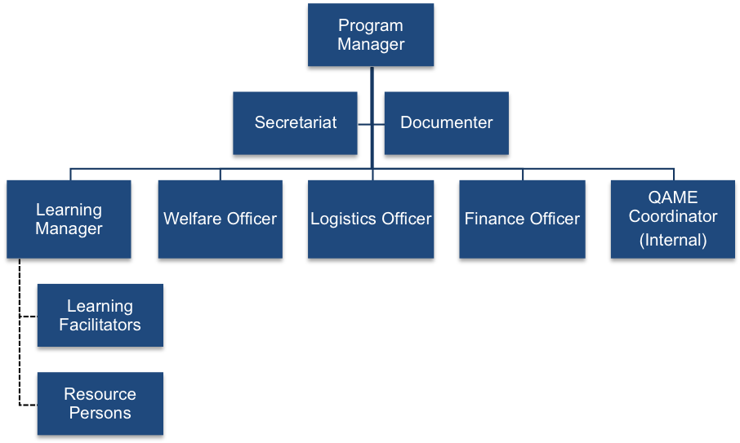
Box 7. Program Management Structure for Face-to Face Training Courses, Seminars and Conferences

- Learning Action Cell (LAC)

LAC aims to develop and support teachers by nurturing their knowledge, attitudes, and competencies in terms of curriculum, instruction, and assessment in their work stations. In the LAC, a group of teachers engages in collaborative learning sessions to solve shared challenges encountered in the school facilitated by the school head or a designated LAC leader. LAC will become the school-based COPs that are positive, caring, and safe spaces.

There are four delivery modes for LAC: group learning, one-on-one learning, supported self-managed learning, and multi-school learning activities.

Below is the LAC composition for group learning or multi-school learning activities.

Box 7. Composition of a Learning Action Cell

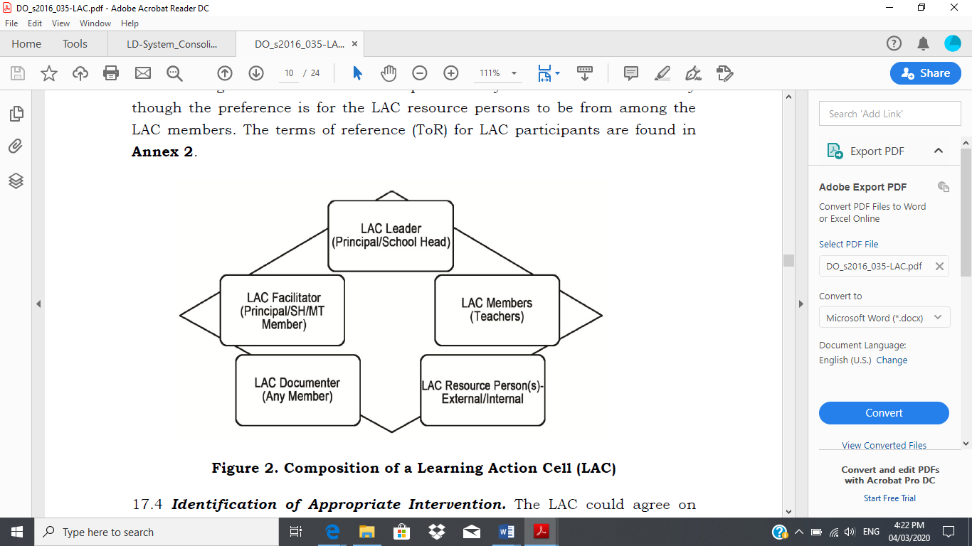

For the roles and responsibilities of LAC members as well as the implementation process of LAC in schools, refer to Annex 2 of DO No. 35, s. 2016.

Annex B
L&D Intervention Completion Report Template

Intervention Title | Indicate full title of the L&D intervention.
Location and Venue | Indicate location and specific venue.
Duration and Dates | Indicate duration (number of days) and dates (from dd/mo/yr - dd/mo/yr) of the L&Dintervention).
Program Manager | Indicate Program Manager’s name, position and office/unit.
Learning Service Providers | Indicate names of facilitators/trainers and their positions.
Number of Learners | Male | (Indicate number) | Female | (Indicate number) | Total | (Indicate total number)
List of Learners | Attach list of invited and confirmed learners. (Attachment 1)
Attendance Record | Attach attendance sheets. (Attachment 2)
Executive Summary | Provide brief summary of the intervention to include:  - Background and rationale  - Intervention objectives  - Highlights of the intervention  - Recommendations and Next Steps
Intervention Objectives | Indicate terminal objective(s) as stated in the intervention design.
Intervention Schedule | Attach detailed L&D intervention design. (Attachment 3)
Intervention Outputs | List down outputs produced by learners during the intervention.
Learning Resource Package | List the resource materials used to conduct the intervention; e.g. session guides, references, etc.
M&E Results | Identify key results of the L&D intervention, based on analysis of monitoring and evaluation data. (Refer to Monitoring and Evaluation Plan.)  Level 1 (Reaction): Post-program/intervention evaluation  - Summary of participants’ post-intervention evaluation  - Summary of Program Manager’s review and evaluation  - Summary of learning service providers’ review and evaluation  Level 2 (Learning):  - Summary of pre- and post-test results  - Summary of outputs produced by the learners during the conduct of the intervention  Attach post-intervention evaluation results (Attachment 4), and pre-and post-test results. (Attachment 5)
General Comments | Provide comments related to elements of intervention design:  - Selection of learners  - Appropriateness and attainability of learning objectives  - Adequacy and organization of content  - Appropriateness of delivery methodologies  - Adequacy and appropriateness of learning resource materials  - Effectiveness of learning service providers  - Others  Provide comments related to program management:  - Pre-delivery preparation  - Delivery  - Post-delivery
Recommendations | Present recommendations to improve intervention design and management.
Financial Report | Provide brief summary of expenditure vis-à-vis budget. Discuss any deviations.  Attach breakdown of expenses vis-à-vis budget: board and lodging, honoraria, training materials, administrative cost, etc. (Attachment 6)
Intervention Completion Report Attachments | - List of learners
 | - Attendance sheets
 | - Detailed L&D design
 | - Post-intervention evaluation results
 | - Pre-and post-test results
 | - Financial report
 | - Documentation

Reflection Questions for Delivery subsystem
For School Head

Thank you for successfully completing the implementation of the Delivery subsystem Cycle 1.

The reflection questions below are aimed at gathering feedback on the experience of your journey in implementing the L&D system. We would also like to ask your insights, and gather your brilliant ideas on how we can further improve the Delivery subsystem.

Each participant is requested to respond to all the three reflections questions immediately after finishing implementation of the subsystem.

- In what way did implementing the Delivery subsystem clarify/improve the management of L&D for TPD in your school?
_____________________________________________________________________________________________________________________________________________________________________________________________________________________________________________

Kindly rate the extent of improvement using the scale 1-4, where 4 is the highest and 1 the lowest, encircle your rating below:

4 – significantly improved
3 – improved
2 – partly improved
1 – no significant improvement

- What top three (3) insights have you gained in implementing the Delivery subsystem?

  - ___________________________________________________________________________
b. ___________________________________________________________________________
c. ___________________________________________________________________________

- To improve the Delivery subsystem, what changes would you like to propose? What additional knowledge and skills would you like to learn?

_____________________________________________________________________________________________________________________________________________________________________________________________________________________________________________

Reflection Questions for Delivery Subsystem
For SDO TPD Coach

Thank you for successfully completing the implementation of the Delivery subsystem Cycle 1.

The reflection questions below are aimed at gathering feedback on the experience of your journey in implementing the L&D system. We would also like to ask your insights from participating, and gather your brilliant ideas on how we can further improve the Delivery subsystem.

Each participant is requested to respond to all the three reflections questions immediately after finishing implementation of the subsystem.

- In what way did implementing the LDNA subsystem as TPD Coach clarify/improve the management of L&D for TPD in your pilot schools?

_____________________________________________________________________________________________________________________________________________________________________________________________________________________________________________

Kindly rate the extent of improvement using the scale 1-4, where 4 is the highest and 1 the lowest, encircle your rating:

4 – significantly improved
3 – improved
2 – partly improved
- – no significant improvement

- What top three (3) new coaching knowledge and skills have you learned?

_____________________________________________________________________________________________________________________________________________________________________________________________________________________________________________

- To improve the Delivery subsystem, what changes would you like to propose? What additional coaching knowledge and skills would you like to learn?

_____________________________________________________________________________________________________________________________________________________________________________________________________________________________________________

Reflection Questions for Delivery subsystem
For SDO L&D Focal Person

Thank you for successfully completing the implementation of the Delivery subsystem Cycle 1.

The reflection questions below are aimed at gathering feedback on the experience of your journey in implementing the L&D system. We would also like to ask your insights, and gather your brilliant ideas on how we can further improve the Delivery subsystem.

Each participant is requested to respond to all the three reflections questions immediately after finishing implementation of the subsystem.

- In what way did implementing the Delivery subsystem as TA Provider clarify/improve the management of L&D for TPD in your Division?

_______________________________________________________________________________________________________________________________________________________________________________________________________________________________________

Kindly rate the extent of improvement using the scale 1-4, where 4 is the highest and 1 the
lowest, encircle your rating:

4 – significantly improved
- – improved
2 – partly improved
1– no significant improvement

- What three (3) new technical assistance knowledge and skills have you learned?

__________________________________________________________________________________________________________________________________________________________________________________________________________________________________________

- To improve the Delivery subsystem, what changes would you like to propose? What additional TA knowledge and skills would you like to learn?

_____________________________________________________________________________________________________________________________________________________________________________________________________________________________________________

Reflection Questions for Delivery subsystem
For Region L&D Focal Person

Thank you for successfully completing the implementation of the Delivery subsystem Cycle 1.

The reflection questions below are aimed at gathering feedback on the experience of your journey in implementing the L&D system. We would also like to ask your insights, and gather your brilliant ideas on how we can further improve the Delivery subsystem.

Each participant is requested to respond to all the three reflections questions immediately after finishing implementation of the subsystem.

- In what way did implementing the quality assurance role for the Delivery subsystem clarify/improve the management of L&D for TPD in your Region?
_____________________________________________________________________________________________________________________________________________________________________________________________________________________________________________

Kindly rate the extent of improvement using the scale 1-4, where 4 is the highest and 1 the lowest, encircle your rating:

4 – significantly improved
3 – improved
2 – partly improved
- – no significant improvement

In what areas do you still need to improve?
_______________________________________________________________________________________________________________________________________________________________________________________________________________________________________

- In what way has your experience in providing technical assistance to the SDO been clarified or improved?
__________________________________________________________________________________________________________________________________________________________________________________________________________________________________________

Kindly rate the extent of improvement using the scale 1-4, where 4 is the highest and 1 the
lowest, encircle your rating:

- – significantly improved
3 - improved
2 – partly improved
1 – no significant improvement

In what areas do you still need to improve?
_______________________________________________________________________________________________________________________________________________________________________________________________________________________________________

- What research and policy agenda will facilitate the implementation of the Delivery subsystem in the schools?

__________________________________________________________________________________________________________________________________________________________________________________________________________________________________________

Refers to the lead office or unit that is identified in the Strategic Plan for Professional Development (SPPD)/Annual Plan for Professional Development (APPD). The Program Owner is primarily responsible for ensuring that an L&D program is carried out to achieve a set of learning outcomes. The L&D program is usually part of the Program Owner’s office/school’s annual work and financial plan.
Please refer to Appendix VII-A (Adult Learning Principles and Conditions) in the L&D System Manual and DepEd Order 1 s. 2020, par. 34-h on Recognition of Programs and Courses)
As an example, a formal training has the following team composition: a) Program manager, b) Learning manager, c) Welfare officer, d) Logistics officer, e) Finance officer, f) Monitoring and Evaluation coordinator, g) Learning facilitators and Resource persons, and h) Documenter.

